RESSAC
Case study: DAL A FPGA implemented in a product with no SW.

Domain: HW

Context and purpose

In the context of µXAV EPS design some HW sub-system/equipment requests a complex component of type FPGA to be implemented.

The purpose of this usecase is to describe a complex component development flow as part of a product development.
To simplify the demonstration, no SW exists into this product (pure HW approach).

The FPGA is a classic one, without additional level of complexity such as embedded IP or internal COTS.

No advanced verification methods (assertion based, model based, formal approach …) are used during this development (to be managed through another usecase slice)

Product & Board Process development is out of the scope of this case study, which will emphasize on FPGA development itself.
Product & Board Process will be described in another usecase slice, taking credit from the current FPGA usecase.

This usecase is based on actual projects that embed partially the proposed process streamlining.

Expected benefits
Streamlined aspects of the proposed process
- Remove the FPGA Specification and intermediate Specification between FPGA & product level specification, including associated activities like traceability, validation & reviews, CM & PA.

- Take credit from product level verification for FPGA physical test, removing dedicated FPGA dedicated physical verification and associated reviews, CM & PA.

- Removing the FPGA Verification intermediate step between Verification procedures (textual) & Test scenarios (tool inputs).

Particularities:
- FPGA complex but not highly complex (no COTS, no IP).
- Integrated Product /Board/FPGA Team.
- Product functionality is mainly performed by the FPGA.
Current standards issues:

Applicable standards: DO254, EASA CM - SWCEH – 001 (AEH), A(M)C 20-152A

Difficulties to apply this approach in application of current standards:
There is no blocking point regarding the current standards, only some interpretation to be carefully managed and discussed with authorities’ representative.

- Gap on DRL in Table A-1 vs. HW Lifecycle data.
- EASA CM – SWCEH – 001 recognizes DAL D process evidences for product is sufficient , while process of the FPGA is expected to be DAL A (product process should be DAL A compliant to be able to take credit of product level activities).

Compliance demonstration could be based on
- Some DO-254 data life cycle and associated activities are merged without lowering the quality.
- Add DAL A objectives to product development process to reconcile with FPGA DAL A Development process.

Process description:

The complete development of the µXAV systems includes several abstraction layers:
Aircraft level as defined in ARP4754 and ARP4761. All the systems of the µXAV are considered as a unique system, i.e as a multi-system (or system of systems). Layer 0 activities include the development of the AV’s operational specification including the µXAV external interfaces, the functional specification and the multi-system’s architecture. The µXAV functions are mapped to the systems.
System level. Each system is considered in isolation with the other systems. This layer is developed independently for each system. Any issue regarding two systems or more is reported to aircraft teams. For each system, activities include the development of the system operational specification, the functional specification and the system architecture. The system functions are mapped to the items. Items integration and verification are performed progressively following availability of items
- For this usecase System Level output is represented by the “Customer Specification”
Item level . Each item is developed separately based on the functions allocated to this item. The allocated functions (ARP4754’s terminology) are synonymous of system requirements allocated to an item. The item developments may use different methods, tools and numbers of development tiers. The items are defined in system architectures. They may consist of:
- Pure software. HW/SW integration is performed at system level.
- One or several hardware components, complex or not. An electronic board is considered as a hardware item
- A combination of SW and HW components, HW/SW integration is performed at item level.
- For this case Item level is represented by the Product that covers different HW items (FPGA, boards) combined at Product level.

This use case addresses the development of product item called FPGA.
Life cycle overview

The following figure describes product development process, including FPGA related process.

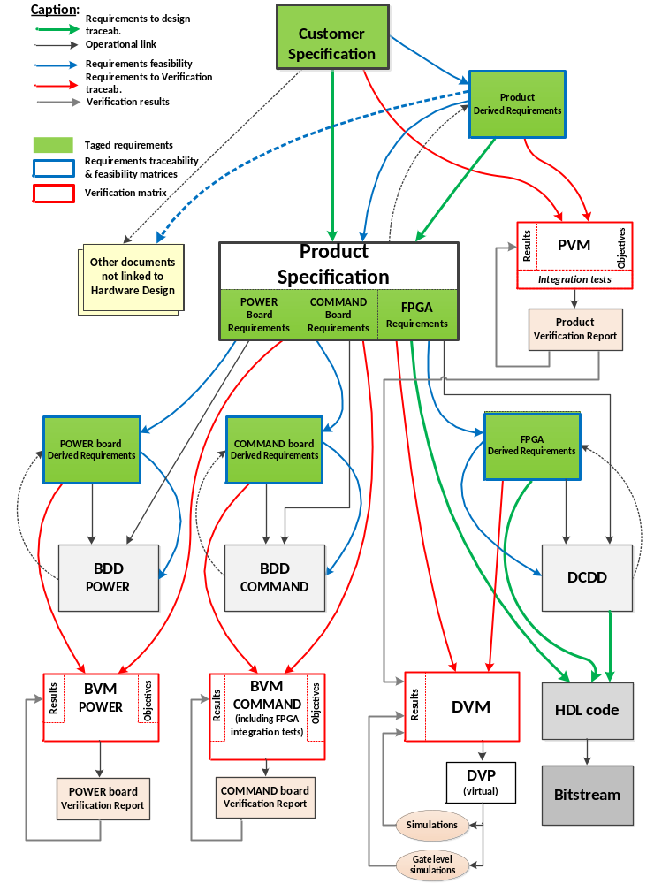

- Planning Process:

Inputs:
Customer Specification (from system/equipment level)

Inputs used for Process/Activity :
Internal processes, standards and Technical Guides (product, board, FPGA)

Outputs:
PHAC
Others plans

Method and environment:
exchanges with stakeholders, including customer, no specific environment

Responsibility:
Project Manager.

Description:
define the development processes and documental artefacts for each item of the product, including the integration activities.

- Requirement Capture, Board/FPGA Requirement Allocation & Product Conceptual Design:

Inputs:
Customer Specification,
others sources (safety requirements, design choices, design constraints, best practices)

Inputs used for Process/Activity :
Supplier internal requirement capture standard

Outputs:
Product Specification,
Product Derived Specification

Method and environment:
Exchanges with stakeholders, no specific environment

Responsibility:
Product Engineer

Description:
- Capture and refining of Customer specification
- Definition of the Product architecture
- Functional decomposition and mapping
- Allocation of functions to Power & Command boards,
- Allocation of functions to FPGA, hosted on the Command board.
- Creation of Derived Requirements in Product Derived Specification (not requested by Customer Specification, from architectural definition and external sources requests)

Errors sources and classes:
Wrong understanding of the customer needs (correctness of capture)
Incomplete coverage of requested functionality
Safety impact of added functionality and constraints
Allocation impossible to implement

Means to address errors sources:
Validation and specification review activities (including safety assessment).

- Specification review/Validation

Data submitted to Process/Activity:
Product Specification,
Product Derived Specification,

Inputs used for Process/Activity:
Customer Specification,
Supplier internal Validation Standard (guide & checklist)

Outputs:
Traceability matrix (Customer Specification <-> Product Specification),
Validation evidences (checklist),
Safety acceptance for Derived requirement

Method and environment:
Specification Review performed by independent peers,
traceability tool as support of the activity

Responsibility:
Design engineer
Peer reviewer

Description:
- Ensure that upper Requirements are all captured by producing a traceability matrix.
- Ensure that requirements are complete, correct, unambiguous, verifiable, and achievable based on checklist.
- Ensure that Derived requirements are identified, and Safety impact analysis accepted by Safety Engineer &/or Customer.

Errors sources and classes:
Common mode: reviewer and writer is the same person
Wrong analysis of impact

Means to address errors sources:
Validation and specification review activities done with independence
Person in charge of these activities have the correct skills
PR management to track errors

Note: There is a Board level Development process but not in the scope of this case study. We address directly FPGA development process.

- FPGA Conceptual & Detailed Design:

Data submitted to Process/Activity:
Product specification requirements allocated to FPGA

Inputs used for Process/Activity:
Internal standards for FPGA

Outputs:
Conceptual & Detailed Design document (including allocation matrix),
FPGA Derived Requirement document

Method and environment:
no specific environment

Responsibility:
FPGA Designer.

Description:
- Architecture/Block Diagram of FPGA with allocation of Requirements to internal blocks
- Functional Description of blocks (inputs, outputs, interfaces, behavior)
- Definition of Clock Tree, Reset mechanism.
- Definition of FPGA constraints, pinout
- Definition of Testability features if necessary (e.g. test port)
- Identification of derived requirements in case of additional functionality not requested at product level (including internal interfaces and communication protocols).
- Analysis of Safety impact for FPGA derived requirements by Safety Engineer &/or Customer.

Errors sources and classes:
- Block description is not correct with regards to covered requirements
- Error in allocation
- Architecture not achievable or not testable
- Additional features and constraints have unacceptable safety impact

Means to address error sources and classes:
- Traceability between block Diagram & Requirements
- Independent Review of the outputs including safety analysis of derived requirements

- VHDL Code generation.

Inputs:
Product Specification,
Product Derived Specification,
Conceptual & Detailed Design document.

Outputs:
VHDL Code,
constraint file,
pinout file.

Method and environment:
Internal Design and coding Standards
Coding rule checker tool (qualified as per DO254)

Responsibility:
FPGA Designer.

Description:
- Manual writing of VHDL code, with embedded traceability
- Manual writing of constraint & pinout files.
➔ Could be replaced by automatic generation in case of assertion or model based approach

Errors sources and classes:
- Error on implementation of Requirements & Conceptual/Detailed Design
- Error on Naming Rules defined in the Coding Standard.
- Error on Design rules Defined in the Coding Standard (Clocked process, positive clock edge, resynchronization of input signal / Clock Domain crossing signal….)
- Additional code not traced to a capture functionality

Means to address error sources and classes:
- Perform Code review vs Requirement/CDD & Design Standard.
- Perform virtual verification activities (simulation)
- Perform elemental analysis (code coverage during virtual verification)
➔ Could be replaced by formal analysis in case of assertion or model based approach

- FPGA VHDL Synthesis & Place/Routing

Inputs:
VHDL code,
constraints & pinout files.

Outputs:
Netlist,
Bitstream,
Warning & Error Synthesis & P/R tools,
pinout mapping file, Usage metrics,
Static Timing Analysis (STA)
Power Consumption simulation.

Method and environment:
internal standard & FPGA Manufacturer Tools.

Responsibility:
FPGA Designer.

Description:
- Generate implementation data (executable/bitstream) from the source code and constraint files.
- Generate intermediate time accurate model (object code/ netlist)
- Generate automatic reports and analysis related to timing, pinout, implementation process

Errors sources and classes:
Implementation tools failed to implement the function
Implementation doesn’t fit all constraints (timing, operating conditions)
Implementation add some unexpected features

Means to address error sources and classes:
- Tools relevant experience
- Use of coding and design rules to limit the risk
- Limit the configurability of tools through constraint file and design rules
- Verification activity
- Review of Tool log files.
- Review of STA results..
- Review of Resources spares for future growth
- Verification of the design (Virtual Verification) : procedure generation

Inputs for Process/Activity:
Product specification & Product Derived Specification requirements allocated to FPGA.

Inputs used for Process/Activity:
internal Verification Standard (Verification Review guide and checklist)

Outputs:
FPGA Verification procedures (Device Virtual Verification Procedures),
Traceability data (Device Verification Matrix)
➔ Could be replaced by automatic generation in case of assertion or model based approach

Method and environment:
Internal verification standard,
Verification tool for dry-run and debug (no independence, no qualification)

Responsibility:
FPGA Verification Engineer.

Description:
- Selection of Verification Method by Requirement
- Manual write of Verification procedure with test scenario, including:
  - Initial conditions,
  - covered FPGA requirements
  - Objectives
  - Scenario, Pass/Failed Criteria
- Generation of Requirement Verification Coverage matrix
Note: procedures are expressed in a language that can be interpreted by simulation tool and is sufficiently documented to be used as a support for a procedure review.

Errors sources and classes:
Incomplete coverage of the requirements
Code oriented verification (common mode)
Foreseeable conditions not covered

Means to address error sources and classes:
Not performed by designer (independence criteria)
Procedure review by independent peer (could be the designer)
Robustness cases to be taken in account

- Verification of the design (Virtual Verification) : Execution & Results

Inputs:
FPGA Verification Procedures,
VHDL Code

Outputs:
Verification results (Device Virtual Verification Results), Code Coverage Results.

Method and environment:
internal Verification Standard (Verification Review guide and checklist),
Simulation Environment Tool & scripts.

Responsibility:
FPGA Verification Engineer.

Description:
- Execution of Verification procedure with test scenario, and analysis of results, with Code Coverage enabled.
- Identification and classification of failed test results.
- Identification and justification of uncovered element.

Errors sources and classes:
Incomplete coverage of the requirements not detected
Foreseeable conditions not covered
Failed criteria not detected, reported, analyzed
Stress error : functions are never verified simultaneously and without sufficient set of input data (miss corner case, stress case …)

Means to address error sources and classes:
Elemental analysis
Failed are tracked by change management process (PR)
Remaining errors (especially stress and corner cases will be detected during physical test)

- Verification of the product and physical test of the FPGA(Product Verification)

Inputs:
Product Specification,
Product Derived Requirement document.

Outputs:
Product Verification procedures
Traceability (Product and FPGA Verification Matrix versus test procedures)
Product verification results

Method and environment:
internal Verification Standard (Verification Review guide and checklist)
Testbench,
tools
Representative environment of the product

Responsibility:
Product Verification Engineer.

Description:
- Relevance of Verification Method by Product Requirement
=> by construction FPGA requirements are a subset of product requirements (except FPGA derived requirements)

- Manual write of Verification procedure with test scenario, including:
  - Initial conditions,
  - Tracing Product requirements
  - Objectives
  - Scenario
  - Pass/Failed Criteria
- Product Requirement Verification Coverage
=> by construction FPGA requirements are a subset of product requirements (except FPGA derived requirements)
- FPGA derived Verification coverage

- Execution of Verification procedure with test scenario, and analysis of results
- Identification and classification of failed test results.
- Identification and justification of uncovered element
- Potentially Post/layout Virtual Verification if some FPGA requirements are not correctly covered (-> same activity than 8 but applied on netlist in place of source code).

Errors sources and classes:
Incomplete coverage of the requirements not detected
Foreseeable conditions not covered
Failed criteria not detected, reported, analyzed

Means to address error sources and classes:
Not performed by designer (independence criteria)
Procedure review by independent peer (could be the designer)
Failed are tracked by change management process (PR)
Robustness cases to be taken in account

Artefacts examples:

<To provide actual extracts of data to clarify the key points of the proposed processes.>

